Padification srs

Date: 2017-06-07

Version: 0.5

McKenzie College SWTS2102

1. Revision History

|  |  |  |  |
| --- | --- | --- | --- |
| Date | Author | Version | Revision Notes |
| 2017-06-06 | William Gale | 0.1 | Heading layout for document. |
| 2017-06-06 | Elie Godbout | 0.2 | Added Sections 2 and 3 being; Conformance and Normative references. |
| 2017-06-06 | Zachary Blue | 0.3 | Added Scope and Definitions, Abbreviations and Acronyms. |
| 2017-06-07 | William Gale | 0.4 | Integrated Player Concept into Section 5.1, Updated Revision History Layout, and Title Page. |
| 2017-06-07 | Elie Godbout | 0.5 | Integrated the Game Overview Concept in section 5.1, Updated revision history, Title page, Table of contents and Added a List of Figures. |
|  |  |  |  |
|  |  |  |  |

1. Table of Contents

I. Revision History 2

II. Table of Contents 3

1 Scope 4

2 Conformance 4

2.1 Intended usage 4

2.2 Conformance to Processes 4

2.3 Conformance to information item content 4

3 Normative References 4

4 Terms, Definitions, and Abbreviated Terms 5

4.1 Terms and Definitions 5

4.2 Acronyms and Abbreviations 6

5 Concepts 7

5.1 Introduction 7

5.1.1 Game overview 7

5.1.2 Player 10

5.2 Requirements Fundamentals 11

5.3 Practical Considerations 11

5.4 Requirement Information Items 11

6 Processes 11

6.1 Requirements Processes 11

6.2 Stakeholder Requirements Definition Process 11

6.3 Requirements Analysis Process 11

6.4 Requirements Engineering Activities in Other Technical Process 11

6.5 Requirements Management 11

7 Information Items 11

8 Guidelines for Information Items 11

9 Information Item Content 11

1. List of Figures

Figure 1: Player information 8

Figure 2: Player ID search 8

Figure 3: Main menu bar 9

Figure 4: Monster box 9

Figure 5: Player information Displayed in Navigation Menu 11

Figure 6: Player Name Change Menu 11

# Scope

Our project PADification will be designed and produced through the following processes: evolving a monster, beating a dungeon, leveling up a monster, selling a monster, and more. Through those processes we will produce a database that contains all the information pertaining to monsters found within the North American version of Gungho’s Puzzle and Dragons mobile videogame. Using that database, we will create a program for the purpose of logging and maintaining a user’s input monsters as well as allow users to search for monsters and simulate team builds. PADification will also allow users to add a wishlist for monsters that they either need or would like to collect in the future.

# Conformance

## Intended usage

The intention of conformance for this SRS document is to help stakeholders understand where the data and information the group has gathered come from and under what format, scope and decree they will follow.

## Conformance to Processes

* The PADification final product aims simulate processes found in the Puzzles and dragons mobile video-game developed by Gungho online entertainment Inc. The main process is as follows:
  + Creation, updates and deletion of teams
    - Leader monster
    - Sub monsters
    - Team name
    - Badge equipped
* The idea behind this is to allow players of puzzles and dragons from around the world to share the teams as well as monsters they own to other players. Something that puzzles and dragons does not permit at the current time.

## Conformance to information item content

* The PADification final product gathers all its information from the puzzles and dragons mobile video-game developed by Gungho online entertainment Inc. as well as from third party website: <http://puzzledragonx.com/com>
* If information found within puzzledragonsx.com should ever prove unreliable, unsure and/or faulty, it is required to have the issue resolved by identifying it within puzzles and dragons.
* Information regarding instances of player information and instances of specific monsters are found within puzzles and dragons by way of the player’s account information.

# Normative References

ISO/IEC/IEEE 29148-2011 SRS International Standard Document

<https://webcache.googleusercontent.com/search?q=cache:OQfOP0Z_vMQJ:https://edisciplinas.usp.br/pluginfile.php/1077344/mod_folder/content/0/iso-iec-ieee-29148-2011.pdf%3Fforcedownload%3D1+&cd=3&hl=en&ct=clnk&gl=ca>

Puzzle and Dragons X

<http://www.puzzledragonx.com/>

“Puzzle and Dragons” game

<https://itunes.apple.com/ca/app/puzzle-dragons-english/id563474464?mt=8>

<https://play.google.com/store/apps/details?id=jp.gungho.padEN&hl=en>

<http://www.gunghoonline.com/games/puzzle-dragons/>

# Terms, Definitions, and Abbreviated Terms

## Terms and Definitions

* + (Plus) stats – Bonus stats applied to HP, ATK, and RCV. Up to 99 + stats can be granted to each stat for a monster for a total of 297. A bonus of +# times 10 is granted to HP, +# times 5 for ATK, and +# times 3 for RCV.
* Active Skill – An modifier belonging to monsters that can be used in dungeons to modify the board, the player’s team or the enemies.
* Assist Monsters – Monsters can be assigned to other monsters. The assisted monster gains the active skill of the assisting monster as well as a possible stat boost while the assisting monster can no longer be brought into dungeons or sold. Not all monsters can be assists.
* Attack – A monster’s statistic that determines the base amount of damage a monster can deal.
* Attribute – A property of a monster that determines the type of damage a monster will deal. A monster can currently have up to two (minimum of one) of five attributes consisting of Fire, Water, Wood, Light, and Dark.
* Awoken Skill – A passive modifier granted to a monster.
* Awoken Skills – A passive modifier a monster may have. All monsters with the same Monster ID have the same Awoken Skills. A monster may have zero to nine of them.
* Database - A structured set of data held in a computer, especially one that is accessible in various ways.
* Dungeon – A section within PAD that allows the user to obtain experience, coins, magic stones, and monsters.
* Egg machine – A feature that allows a user to use magic stones or pal points to procure a random monster from a pool of monsters.
* Evolution - Monsters can evolve/devolve into other monsters when certain conditions are met.
* Health Points – A monster’s statistic that determines how much damage a monster can take before a player dies.
* Latent Awoken Skills - A type of awoken skill that you assign to a monster.
* Latent skills – A passive modifier that can be assigned to monsters through power-up/fusion. Up to a max of 6 can be added to a single monster.
* Leader Skill - An in-dungeon modifier granted to the player based on the leader monster. Not all monsters have one.
* Magic stones – A in-game currency within that can be used to restoring stamina, buying eggs from the egg machine, and allowing the user to continue a dungeon upon death (where applicable). Purchasable with real money.
* Mail System – An in-game communications system through which players can communicate with other players and admin. Monsters and currency are able to be obtained through the mail system.
* Monster – Characters that can be obtained within the game through dungeons, mail, and egg machines.
* Monster Assist – A monster assigned to another monster to offer a second active skill and slight stat boost.
* Monster Experience – An indicator of a monster’s current progression towards it’s maximum potential.
* Monster ID – All unique integer identifier assigned to each monster.
* Monster Level – A statistic of a monster that acts as a modifier based on a monster’s experience.
* Monster Name - All monsters have a name that are unique (if only by case).
* Monster Types - Monsters have 1-3 types. There are currently 12 different types a monster may have.
* Pal points – An in-game currency collected from helping friends in dungeons, using friends’ monsters in dungeons, and logging in each day that is used to purchase pulls from the Pal Egg machine.
* Puzzle and Dragons – A game involving monster collection and team creation required to defeat more difficult Dungeons.
* Rank – a player grading system that determines the amount of stamina, friends, features the Player can have.
* Rarity - An indicator of how common or uncommon a monster is.
* Recovery – A monster’s statistic that determines the base amount of health a monster will heal for the team.
* Stamina – An integer value that determines a player’s access to a dungeon. Entering a dungeon will take a specified amount of stamina from the player’s current stamina count. Stamina recharges over time up or upon ranking up, to the maximum amount a player can hold. The amount a player can hold is based on rank.
* Type – A classification of a monster. A monster can currently have up to three (minimum of one) of (currently) twelve types.

## Acronyms and Abbreviations

* PAD – Puzzles and Dragons
* HP – Health Points
* ATK – Attack
* RCV – Recovery
* RDBMS – Remote Database Management service
* DB – Database
* NA – North America

# Concepts

## Introduction

### Game overview

Puzzles and Dragons is a video-game developed by Gungho entertainment Inc. for mobile platforms. The objective of this Puzzles and Dragons is to collect monsters by way of various methods, create teams with these monsters in order to complete dungeons which grants the player with various rewards such as new monsters and in-game currency. Clearing dungeons also push a player’s account by way of experience points. This effectively increases a player’s ability to access more advanced parts of the video-game. The rewards obtained can be used to enhance their monsters and be used to accomplish other tasks.

Compatible mobile devices:

* Apple IOS 6.0 and higher
* Android 2.3 – 7.0
* Kindle
  + Fire (2nd generation)
  + Kindle HP
  + Kindle Fire HDX
* Puzzles and Dragons requires the player to create an account in order to use the application. Once the account is created or when signing in, A player’s account will contain the player’s personal information and account information such as currency, rank, monsters, cleared dungeons, etc.
  + 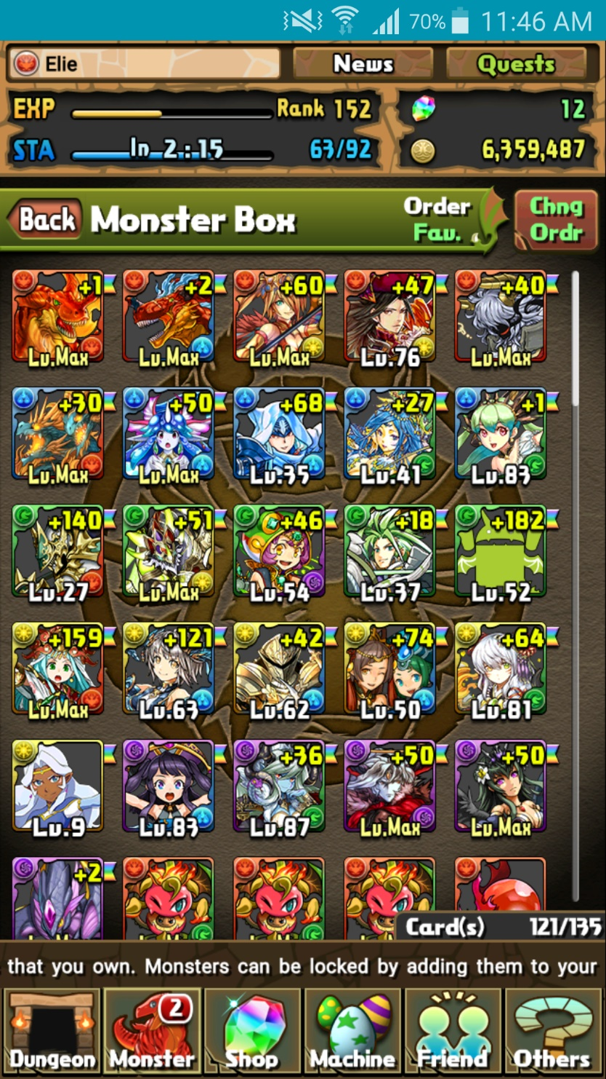Rank

Figure : Player information

* + Current & Max Stamina
  + 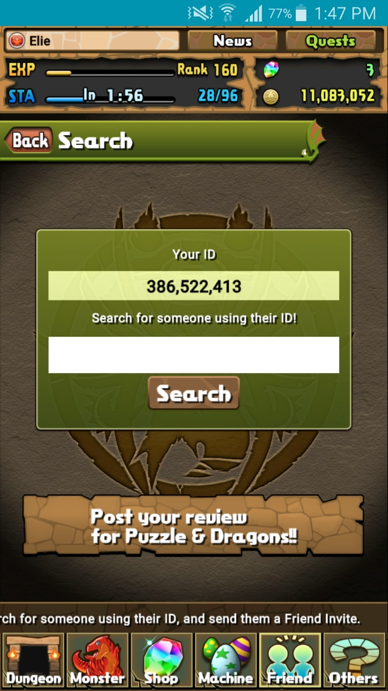Currency

Figure : Player ID search

* + - Magic stones
    - Coins
    - Pal points
    - Monster points
  + Attribute
  + Player ID
* 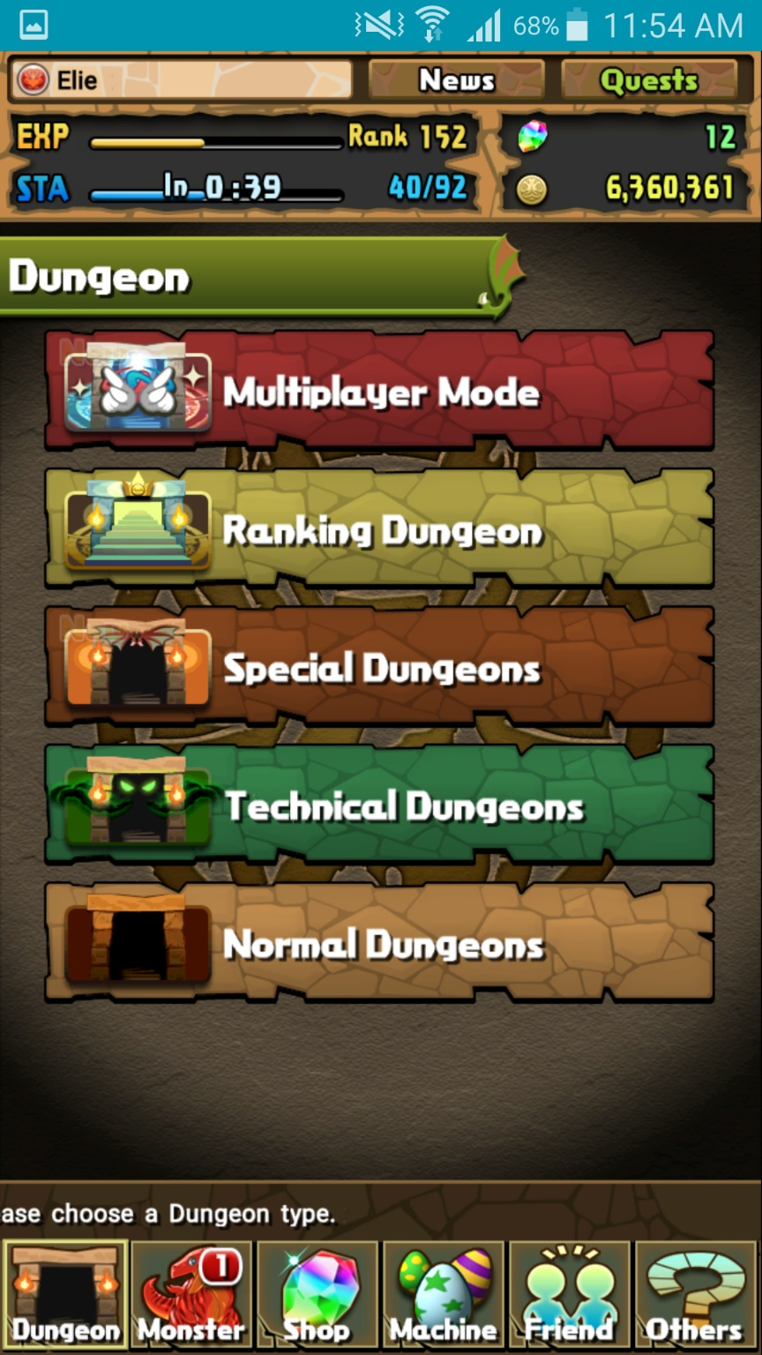Puzzles and Dragons contains an ever-present menu system located at the bottom of the game window. (except when in gameplay)

Figure : Main menu bar

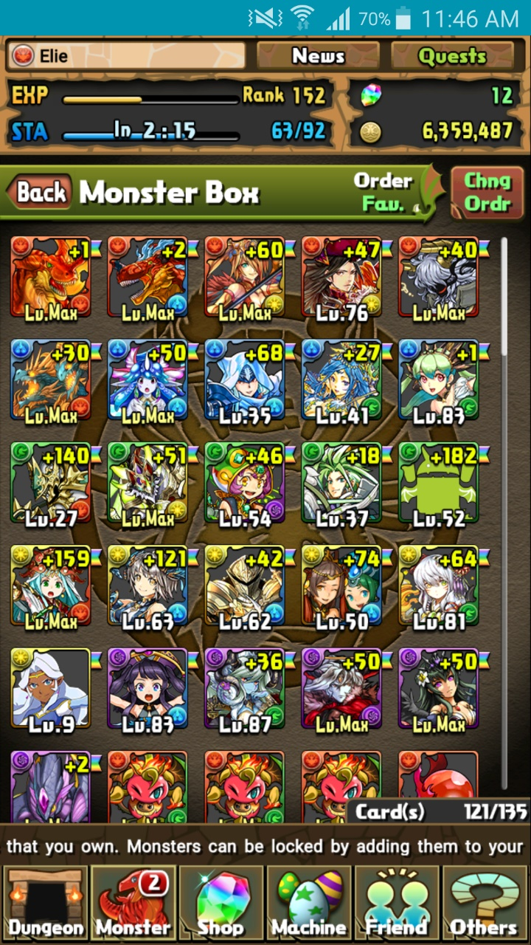

Figure : Monster box

* From the Monster option on the main menu, a player has access to a list of monsters they’ve acquired while playing known as the monster box. Within this section, a player can select a number of additional options such as:
  + Viewing their monster collection via Monster Box
  + Sell Monsters
  + Manage Assists
  + Evolve or Ultimate-evolve monsters
  + Enhance monsters via level-up Fusion
  + Edit teams for use in dungeons
* From the Dungeons option, players can access the main gameplay of Puzzles and Dragons known as dungeons. There exist many types of dungeons:
  + Normal
  + Technical
  + Special
  + Multiplayer
  + Ranking
  + Coin dungeons
* From the Shop option, players have access to shops in Puzzles and Dragons. Here, a player can perform microtransactions to buy an in-game currency known as Magic Stones. Further more, you can spend these Magic Stones to purchase certain items such as monsters. A player can also spend coins for other items.
  + Magic stone shop (microtransactions)
  + Monster shop
  + Coin dungeons
  + Refill stamina
  + Expand monster box
  + Expand friend list capacity
* From the machine option, a player has access to a lottery style monster generator known in-game as egg machines. These allow players to spend in-game currency to obtain randomly chosen monsters.
  + Pal egg machine
  + Rare egg machine
  + Special event egg machine (This option is not always available)
* From the Friend option, players may interact with other players by sending invitations to others and register them as friends by sharing player IDs. Players can then choose to send messages to their friends and best friends.
  + View registered friends via Friend List
  + Search for players and view your player ID in ID search
  + View messages and notifications in Mail / Invites
  + Send Mail is used to send messages specifically to registered friends
* From the Others option, players have access to a wide range of options concerning the functions of the application, links to external sources, services about the game, information about Gungho, options to change certain settings, etc.
  + Links
  + Monster Book
  + Options
  + Help
  + User info
  + Support
  + Device change
  + Terms of service etc.
  + Data Installation
  + Screen Display Settings
  + Return to Title Screen
* Found on the top right corner, players have access to quests. These offer rewards to players once specific conditions are met. Each quest is classified within categories and state the specific request needed to obtain the reward associated to a given quest.
  + Degree of difficulty
  + Descended
  + Maniacs
* On the top corner of the window, next to the quests option, players have access to a news section to view the latest information on the daily activities of Puzzles and Dragons and/or any changes and updates done to the application. All these are composed by Gungho.

### Player

The Representation of the entity playing Puzzles and Dragons, It Holds all information related to the specific user, it consists of the following Elements:

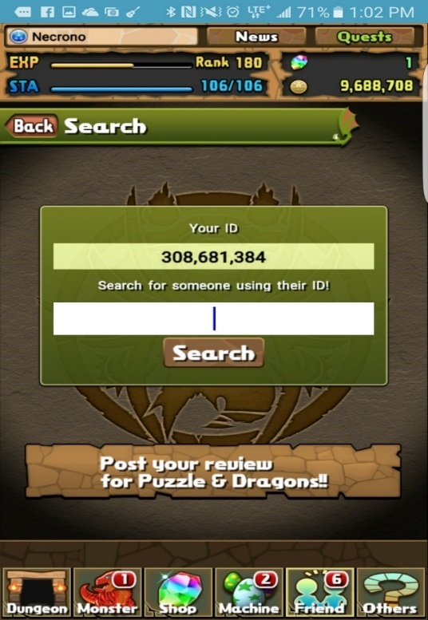

Starting Attribute and Name

Experience, Rank, and stamina

Player ID

Magic Stones and Coins

Quests

Figure : Player information Displayed in Navigation Menu

* Player ID A Unique 9 Digit identifier of the Player, Used for account identification, and migration / recovery.
* 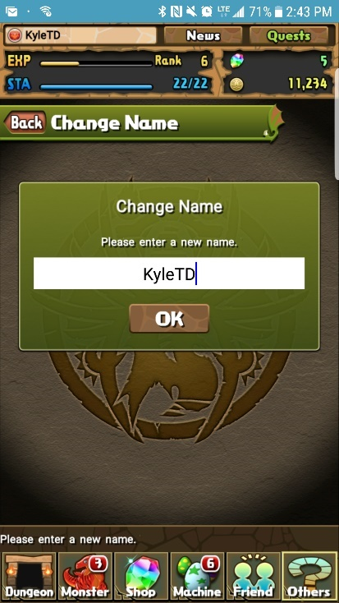Name Chosen by the Player; Displayed to other Players, but not used for account identification as it is not unique and changeable at any time.

Figure : Player Name Change Menu

* Experience Obtained through completion of dungeons.
* Rank An integer value determined by your current exp.
* Max Stamina The maximum amount of Stamina a Player can store, Increase’s with Rank
* Stamina An integer value based on level that regenerates 1 every 3 mins, fills on Rank up or with a magic stone Purchase, spent when entering Dungeons.
* Coins An in-Game Currency, Used in power-up fusion, and Dungeon Purchases.
* Magic Stones An in-Game Currency Gained from first time Dungeon Completion, Real money purchase, promotional events. Used to pull Rare Egg Machine, Restore Stamina, fully heal team on lose.
* Monster points An in-Game currency used to purchase monsters.
* Pal Points An in-Game currency earned from using a Helper during Dungeons.
* Quests A set of Goals to complete which grant various Rewards, In the form of Dungeons, Badges, Monsters and Currency.
* Collection The Players collection of currently owned Monsters.
* Monster Book A book of all monster the Player has seen and captured.
* Starting Attribute Selected by starting monster picked, Places icon next to name. Determines player’s time group as well as their ID
* Teams Groups of 1-5 monsters picked from the players Monster Collection, used to play dungeons.
* Friends A collection of players friended by the Player, Allows use of friend leaders as helpers.

## Requirements Fundamentals

## Practical Considerations

## Requirement Information Items

# Processes

## Requirements Processes

## Stakeholder Requirements Definition Process

## Requirements Analysis Process

## Requirements Engineering Activities in Other Technical Process

## Requirements Management

# Information Items

# Guidelines for Information Items

# Information Item Content